**Document History**

|  |  |  |  |  |  |
| --- | --- | --- | --- | --- | --- |
| A=Added, M=Modified, D=Delete | | | | | |
| **Version No** | **Date** | **Section No** | **A/M/D** | **Description of Change** | **Author** |
| 1.0 | 04-April-2021 |  | A | Initial | Mahfuzur Rahman |
| 1.1 | 27-Oct -2021 |  | A | Add Product Variant Config for Manufacturing | Aynul Islam Tamjid |
|  |  |  |  |  |  |
|  |  |  |  |  |  |

**Before Ignore Tally Make sure mention below point are work properly**

1. Month wise Possible Combinations **P&L** reports are done.
2. Month wise **Balance Sheet** reports are done.
3. Make sure All Products “**Cost Per Unit**” are Set
4. **Check & Compare** between **Daily** Production Entry & Asset movement (RM, PM, FG) Journal Entry.
5. **Check & Compare** between **Daily** Delivery Entries, COGS Journal Entries & Invoice Journal Entries.
6. Make sure all Journal Entries entered by relevant “**Cost Center**”, ”**Operating Unit**” etc.
7. Set a **Specific Cutoff Date** & at this Date Individual **Asset** **GL Value** & **Inventory Valuation** are Match.

**For Sales**

**Account Configurations**

Make sure All Valid **Customer** are entered with mention below fields:

**Account Receivable:**  "Appropriate Account Receivable" GL

**Account Payable**: "**302001001001 Default-AP**" GL

Make Sure All **Saleable** **Product** are entered with mention below fields:

**Product Type:** “**Stockable Product**”

**Can be Manufactured:** “**True**”

**Internal Category**: “Appropriate Value”

**Unit of Measure:** “Appropriate Value”

**Income Account:** “Appropriate Default Income GL”

**COGS Account (RM):** “Appropriate Value”

**COGS Account (PM):** “Appropriate Value”

**Cost Center:** “Appropriate Value”

**Credited Account:** “Possible Combination GL Mapped”

Make Sure All **Product Variants** are entered with mention below fields:

**Cost per unit:** “Appropriate Value”

Make Sure All **FG Product Categories** are entered with mention below fields:

**Costing Method: “Average Price”**

**Inventory Valuation: “Periodic (manual)”**

**Stock Valuation Account:** “Appropriate Stock GL"

**Stock Journal: “Stock Journal (BDT)”**

**Journal Entries Monitoring**

1. Make sure Currency Conversion Rate are Proper value for Foreign Currency Invoice at Customer Invoice Validation and check Journal Entry.
2. Make sure Customer Collection Journal Entry at Customer Collection & Cheque Receive.
3. ***Make sure LC Collection Journal Entry at Customer LC Collection.
4. ***Compare between Daily Production Entry & Asset movement (RM, PM, FG) Journal Entry.
5. ***Compare between Daily Delivery Entries, COGS Journal Entries & Invoice Journal Entries.
6. ***Make sure all Journal Entries entered by relevant “Cost Center”, ”Operating Unit” etc.

**For Purchase**

**Account Configurations**

Make sure All Valid **Vendor** are entered with mention below fields:

**Account Receivable:**  "**102008000001 Default-AR**" GL

**Account Payable**: "Appropriate Account Payable" GL

Make Sure All **Purchasable** **Product** are entered with mention below fields:

**Product Type:** “Stockable Product/ Product” (If Consumable then Stockable Product, else Product)

**Internal Category**: “Appropriate Value”

**Unit of Measure:** “Appropriate Value”

**Cost per unit:** “Appropriate Value”

Make Sure All **Purchasable** **Product Categories** are entered with mention below fields:

**Costing Method: “Average Price”**

**Inventory Valuation: “Periodic (manual)”**

**Expense Account:** “Appropriate Stock GL"

**Stock Valuation Account:** “Appropriate Stock GL"

**Stock Journal: “Stock Journal (BDT)”**

**Journal Entries Monitoring**

1. Make sure Vendor Payment Journal.
2. ***Make sure Product “Cost per unit” are updated at Stock Update for Local Purchase by using Average Costing Method. Unit Price will coming from PO Unit Price.
3. ***At Foreign Purchase, Product “Cost per unit” must update by manually after Product Receive and also before Production. Remember that, when it is Foreign Purchase, System will not update Product “Cost per unit” automatically. System will update automatically “Cost per Unit” only when it is Local Purchase.

**For Manufacture**

**Product Variant Configurations**

**Ratio In Percentage:** “Appropriate Value”

**Manufacturing Tab**: Set operating unit wise Manufacturing type. (Reference below)

**Case-1:** (a)If you don’t configure the type for any operating unit than the system will consider the type as Production. (b) If you configure the type for one operating unit, the system will consider the type as Production for others operating unit.

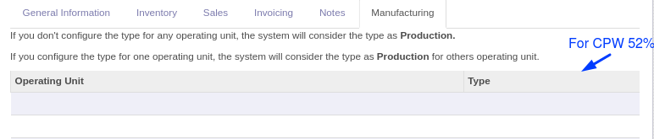

**Case-2:** If you configure the type Production for any operating unit, the system will consider the type as Production.

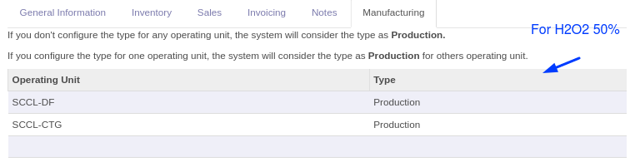

**Case-3:** If you configure the type Conversion for any operating unit, the system will consider the type as Conversion.

